**Logical Probe Pen v1.0**

**Schematic:**

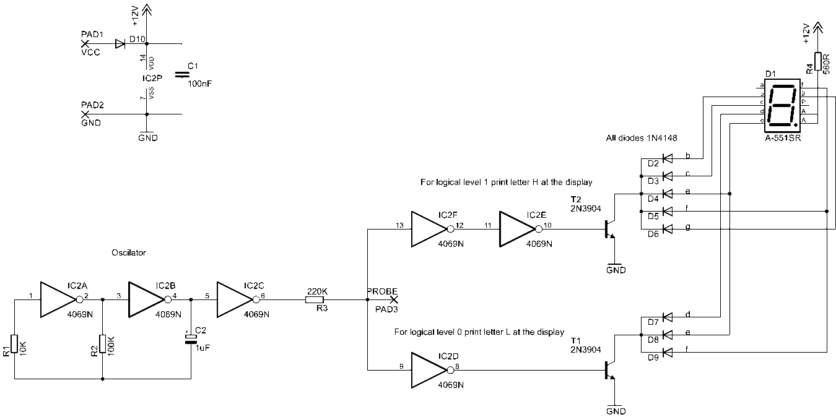

**Board, silkscreen: Board, copper side vias: Board, pads mask:**

